
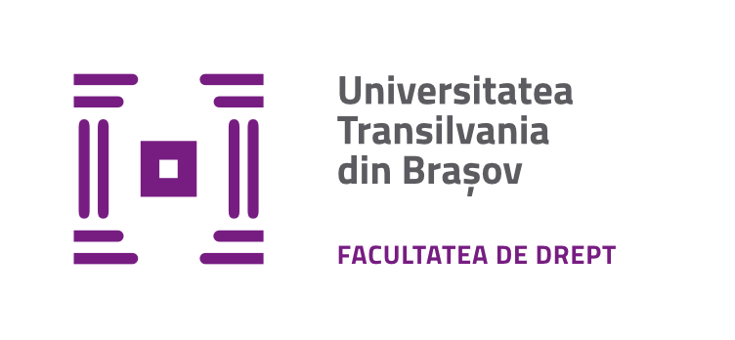
B-dul Eroilor 25
500030 – Brașov
tel.: (+40) 268.471.044
f-dr@unitbv.ro | www.unitbv.ro/drept

Transilvania International Law Conference - 2023
„Current Issues within EU and EU Member States: Converging and Diverging Legal Trends”, 6th edition
Brașov, November 17th 2023

CALL FOR Conference paper presentation

Author/First author |  |  |  |  |  |  |  |  | Co-author
First name |  |  |  |  |  |  |  |  | First name
Last name |  |  |  |  |  |  |  |  | Last name
Academic/ Professional title |  |  |  |  |  |  |  |  | Academic/ Professional title
Professional affiliation (Institution/  Organization) |  |  |  |  |  |  |  |  | Professional affiliation  (Institution/  Organization)
Contact details |  |  |  |  |  |  |  |  | Contact details
Cell phone: |  |  |  |  |  | Email: |  |  | Cell phone: |  |  | Email:
Title of the paper
Keywords
Abstract
Conference Topics (please mark with an X the section you submit for)
Section 1:  Private Law |  |  |  |  |  |  | Section 2:  Public Law |  |  |  | Section 3:  Criminal Sciences

Important Deadlines:
Registration and Submission of Abstracts: 29 September
Notification of Abstract Acceptance: 2 October
Full Paper Submission: 23 October
Notification of Full Papers Acceptance for Presentation at the Conference: 6 November 2023
Final Program Publication on the Web Page: 13 November 2023
Conference: 17 November 2023.

Please see http://webbut.unitbv.ro/public/site/documents/admin/Template_Seria_VII_2023.doc.
Ibidem.

